Incident Lifecycle Automation in ServiceNow
Problem Statement
Organizations receive a large number of IT incidents every day, such as system failures, application errors, network issues, access problems, and hardware-related issues. When these incidents are handled manually, organizations may face delays in incident assignment, improper prioritization, lack of status visibility, missed Service Level Agreement (SLA) deadlines, and difficulty in tracking the complete lifecycle of an incident.
Traditional incident-handling processes often depend heavily on manual activities such as creating tickets, assigning them to support teams, updating statuses, monitoring SLAs, and notifying users. This can result in inefficient resource utilization and delayed resolution of critical incidents.
Therefore, there is a need for an automated incident management system that can capture incidents, classify and prioritize them, automatically assign them to appropriate support groups, track their progress, monitor SLA deadlines, send notifications, and ensure that incidents move through a well-defined lifecycle until resolution and closure.
The proposed project, “Incident Lifecycle Automation in ServiceNow,” aims to develop an automated incident management workflow using the ServiceNow platform. The system will reduce manual intervention, improve incident tracking, ensure timely resolution, and provide better visibility into the overall incident management process.
1. Ideation Phase
The ideation phase focuses on identifying a real-world problem and developing an initial idea for solving it using ServiceNow.
1.1 Identification of the Problem
The project idea was developed by studying common challenges faced by IT support teams in organizations. IT teams frequently receive incidents from employees or customers. Handling these incidents manually can lead to:
- Delays in incident assignment.
- Incorrect prioritization of incidents.
- Difficulty in tracking incident status.
- Missed SLA deadlines.
- Lack of automated notifications.
- Repeated manual activities.
- Difficulty in identifying unresolved or overdue incidents.
- Poor visibility into incident resolution performance.
1.2 Proposed Solution
To overcome these challenges, the proposed solution is Incident Lifecycle Automation in ServiceNow.
The system will automate major activities involved in the incident lifecycle, including:
Incident Creation → Categorization → Prioritization → Assignment → Investigation → Resolution → Closure
Automation will be implemented using ServiceNow features such as:
- Incident Management
- Business Rules
- Client Scripts
- UI Policies
- Workflows/Flow Designer
- Notifications
- SLA Management
- Assignment Rules
- Reports and Dashboards
1.3 Objectives
The major objectives of the project are:
- To automate the incident management lifecycle.
- To reduce manual intervention in incident handling.
- To automatically assign incidents to appropriate support groups.
- To prioritize incidents based on their impact and urgency.
- To monitor SLA deadlines.
- To notify users and support teams about important incident updates.
- To maintain a complete history of incident activities.
- To improve incident resolution time.
- To provide reports and dashboards for monitoring incident performance.
2. Requirement Analysis
Requirement analysis identifies what the system should do and what features are required to implement the proposed solution.
2.1 Functional Requirements
The system should provide the following functionality:
1. Incident Creation
Users should be able to create an incident by providing information such as:
- Caller/User
- Short Description
- Description
- Category
- Subcategory
- Impact
- Urgency
- Configuration Item
- Contact Type
2. Incident Classification
The system should classify incidents based on their category and subcategory.
For example:
Category | Subcategory
Software | Application Error
Hardware | Laptop
Network | Internet
Database | Database Access
Access | Login Problem
3. Incident Prioritization
The system should determine the priority of an incident based on Impact and Urgency.
For example:
High Impact + High Urgency → Critical Priority
This ensures that important incidents receive immediate attention.
4. Automatic Assignment
Incidents should automatically be assigned to the appropriate support group based on their category or issue type.
Example:
Network Issue
↓
Network Support Group
Laptop Issue
↓
Hardware Support Group
5. SLA Monitoring
The system should monitor the time taken to respond to and resolve incidents.
If an incident is approaching its SLA deadline, the system can notify the responsible support team.
6. Notifications
Automatic notifications should be generated for important events such as:
- Incident creation.
- Incident assignment.
- Incident status change.
- Incident resolution.
- SLA approaching.
- SLA breach.
7. Incident State Management
The incident should move through predefined states:
New
↓
In Progress
↓
On Hold
↓
Resolved
↓
Closed
8. Incident Resolution
The assigned technician should be able to provide:
- Resolution notes.
- Resolution code.
- Resolution information.
9. Incident Closure
After successful resolution and validation, the incident should be closed according to the defined process.
10. Reporting and Dashboard
The system should provide reports such as:
- Number of incidents.
- Open incidents.
- Resolved incidents.
- Critical incidents.
- Incidents by category.
- Incidents by assignment group.
- SLA breached incidents.
- Average resolution time.

2.2 Non-Functional Requirements
The system should satisfy the following requirements:
Performance
The system should process incident requests efficiently.
Security
Only authorized users should be allowed to perform specific incident-management activities.
Reliability
Incident information should be stored accurately without data loss.
Usability
The system should provide a simple interface for creating and managing incidents.
Maintainability
The automation should be easy to modify when business requirements change.
Scalability
The system should be capable of handling an increasing number of incidents and users.
3. Project Design Phase
The project design phase defines the architecture, workflow, database structure, and automation components of the system.
3.1 System Architecture
The proposed system can be represented as:
User / Employee
│
↓
Incident Creation
│
↓
Incident Management
│
┌──────────┴──────────┐
↓ ↓
Classification Prioritization
│ │
└──────────┬──────────┘
↓
Automatic Assignment
│
↓
SLA Monitoring
│
↓
Support Team
│
↓
Investigation
│
↓
Resolution
│
↓
Closure
3.2 Incident Lifecycle Design
The lifecycle of an incident is designed as follows:
NEW
│
↓
ASSIGNED
│
↓
IN PROGRESS
│
├────────→ ON HOLD
│ │
│ ↓
│ IN PROGRESS
│
↓
RESOLVED
│
↓
CLOSED
3.3 ServiceNow Components
The project will use the following ServiceNow components:
Component | Purpose
Incident Table | Stores incident information
Business Rules | Automates server-side logic
Client Scripts | Controls form behavior
UI Policies | Controls field visibility/mandatory state
Flow Designer | Automates incident workflows
Assignment Rules | Automatically assigns incidents
Notifications | Sends automated messages
SLA | Tracks response/resolution deadlines
Reports | Analyzes incident data
Dashboards | Provides visual monitoring
3.4 Database/Data Design
The primary data entity is the Incident.
Important fields include:
- Incident Number
- Caller
- Short Description
- Description
- Category
- Subcategory
- Impact
- Urgency
- Priority
- Assignment Group
- Assigned To
- State
- SLA
- Work Notes
- Additional Comments
- Resolution Code
- Resolution Notes
- Created Date
- Resolved Date
- Closed Date
4. Project Planning Phase
The planning phase defines how the project will be implemented and divided into different activities.
4.1 Project Modules
The project can be divided into the following modules:
Module 1 – Incident Creation
Creation and submission of incidents.
Module 2 – Incident Classification
Categorization and subcategorization of incidents.
Module 3 – Priority Automation
Automatic calculation or determination of incident priority.
Module 4 – Assignment Automation
Automatic assignment of incidents to appropriate support groups.
Module 5 – SLA Management
Tracking incident response and resolution deadlines.
Module 6 – Notification Management
Sending automated notifications to users and support teams.
Module 7 – Incident Resolution
Technicians investigate and resolve incidents.
Module 8 – Incident Closure
Completed incidents are validated and closed.
Module 9 – Reporting and Dashboard
Provides management-level visibility into incident performance.
4.2 Project Timeline
A sample implementation plan can be:
Phase | Activities | Duration
Week 1 | Problem identification and ideation | 1 Week
Week 2 | Requirement analysis | 1 Week
Week 3 | System and workflow design | 1 Week
Week 4 | ServiceNow configuration | 1 Week
Week 5 | Incident automation development | 1 Week
Week 6 | SLA and notification implementation | 1 Week
Week 7 | Testing and debugging | 1 Week
Week 8 | Reports, dashboard and documentation | 1 Week
5. Project Development Phase
The development phase involves implementing the planned solution in ServiceNow.
5.1 Incident Module Development
The Incident Management module will be configured to allow users to create and manage incidents.
The incident form will contain fields such as:
Caller
Short Description
Description
Category
Subcategory
Impact
Urgency
Priority
Assignment Group
Assigned To
State
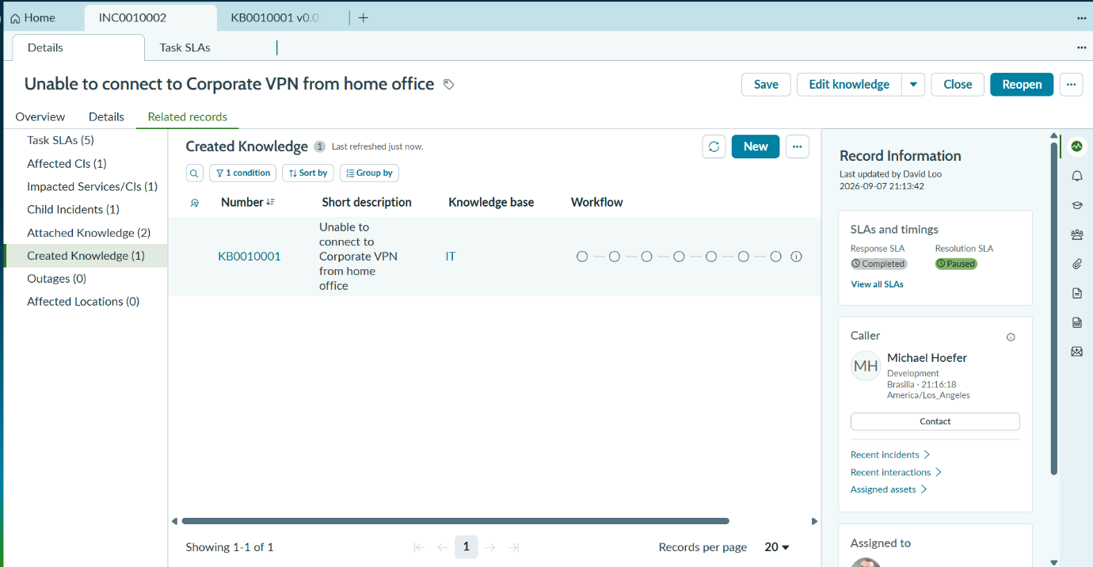
5.2 Priority Automation
The system will determine the priority based on impact and urgency.
Example:
Impact + Urgency
↓
Priority Calculation
↓
Incident Priority
This helps support teams identify which incidents require immediate attention.
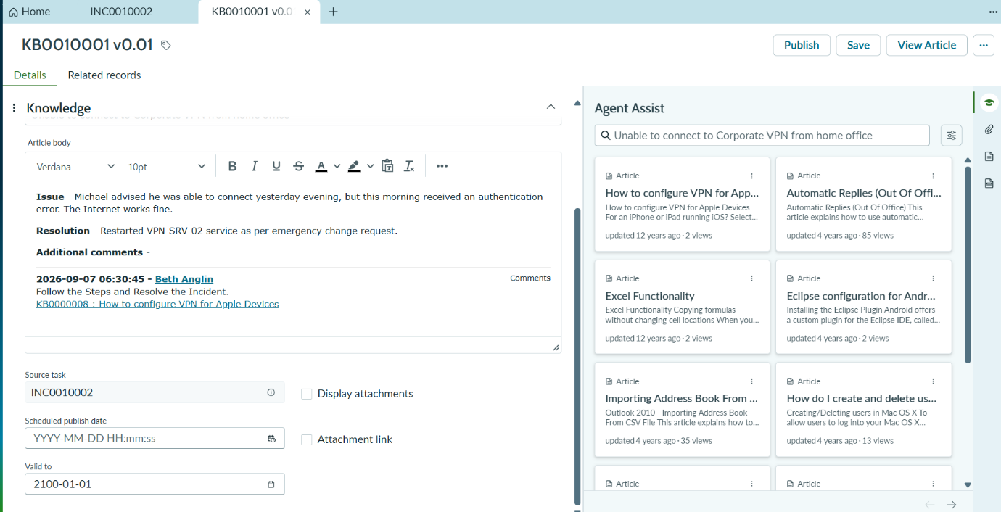
5.3 Automatic Assignment
Assignment rules will be configured to automatically select the appropriate assignment group.
Example:
Category = Network
↓
Network Support Group
Category = Hardware
↓
Hardware Support Group
This reduces the need for manual assignment.
5.4 Workflow Automation
The incident lifecycle will be automated using Flow Designer/workflow automation.
Example:
Incident Created
↓
Check Category
↓
Determine Priority
↓
Assign Support Group
↓
Start SLA
↓
Notify Assigned Team
↓
Investigation
↓
Resolution
↓
Notify User
↓
Closure
5.5 SLA Implementation
SLAs will be configured to track incident response and resolution times.
The system will monitor:
- SLA Start
- SLA Progress
- SLA Warning
- SLA Breach
- SLA Completion
For example:
Incident Created
↓
SLA Started
↓
Approaching Deadline
↓
Notification
↓
Resolved
5.6 Notification Development
Notifications will be configured for important incident events.
Examples:
Incident Created → Notify support team.
Incident Assigned → Notify assigned technician.
Incident Resolved → Notify caller.
SLA Near Breach → Notify support team.
SLA Breached → Notify responsible team/manager.
5.7 Business Rules
Business Rules can be used to perform server-side automation.
Examples include:
- Automatically updating incident fields.
- Validating incident information.
- Updating related records.
- Triggering additional actions when incident states change.
5.8 Client Scripts
Client Scripts can be used to control the behavior of the incident form.
Examples:
- Making fields mandatory.
- Automatically populating fields.
- Validating user input.
- Showing or hiding fields based on conditions.
5.9 Testing
After development, the system will be tested using different scenarios.
Test Case | Expected Result
Create incident | Incident should be created
Select Network category | Network group should be assigned
Set high impact and urgency | Appropriate priority should be generated
Assign incident | Technician should receive notification
SLA approaching | Warning notification should be generated
Resolve incident | Caller should receive resolution notification
Close incident | Incident should move to Closed state
5.10 Reports and Dashboard
Finally, reports and dashboards will be created to monitor the performance of the incident management system.
Possible dashboard components include:
- Total Incidents
- Open Incidents
- Resolved Incidents
- Critical Incidents
- SLA Breaches
- Incidents by Category
- Incidents by Assignment Group
- Average Resolution Time
Overall Project Flow
The complete project can be summarized as:
PROBLEM IDENTIFICATION
↓
IDEATION
↓
REQUIREMENT ANALYSIS
↓
SYSTEM DESIGN
↓
PROJECT PLANNING
↓
SERVICENOW DEVELOPMENT
↓
┌─────────────────────────┐
│ Incident Creation │
│ ↓ │
│ Classification │
│ ↓ │
│ Prioritization │
│ ↓ │
│ Assignment │
│ ↓ │
│ SLA Monitoring │
│ ↓ │
│ Investigation │
│ ↓ │
│ Resolution │
│ ↓ │
│ Closure │
└─────────────────────────┘
↓
TESTING
↓
REPORT & DASHBOARD
↓
FINAL SOLUTION
Expected Outcome
The completed Incident Lifecycle Automation in ServiceNow project will provide a structured and automated approach to incident management. It will minimize manual activities, improve incident assignment and prioritization, monitor SLA compliance, provide timely notifications, and give organizations better visibility into their incident-resolution process.
This structure is suitable for a B.Tech project document, and the next sections you would typically add are Technology Used, Implementation/Screenshots, Testing, Results, Advantages, Limitations, Future Scope, and Conclusion.

